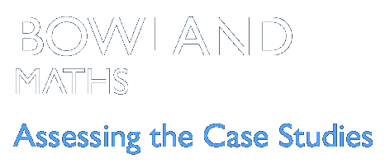 | Product Wars  Assessing the learning

Case Study description

Pupils use their statistical, number and geometrical knowledge to design a new smoothie.
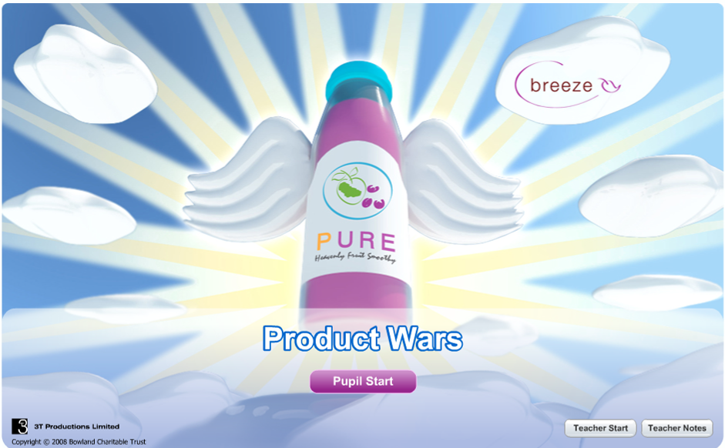
Suitability National Curriculum levels 5 to 8
Time The assessments can be made during the time for the case study.
Resources The resources are listed in the case study. In trials, some pupils completed the activity by making their smoothies. This proved a real motivator!

Opportunities to assess Key Processes
During trials, some teachers waited until lesson 4 to make their assessments of all the Key Processes, but most found it more manageable (and also helpful to pupils) if the assessment was undertaken as the Case Study proceeded.
- Representing: during lessons 1, 2 and 3
- Analysing: during lessons 1, 2 and 3
- Interpreting and evaluating: during lessons 1, 2 and 3
- Communicating and reflecting: during lesson 4.
In addition to assessment of the Key Processes, there are opportunities to assess Range and Content (detail is within the case study) and some of the other personal, learning and thinking skills, particularly for ‘team workers’.
In the trials, pupils were asked to present their findings (in lesson 4), which provided good opportunities to assess Key Processes. Pupils should be forewarned of this at the start of the Case Study so that they can ensure the work they do is suitable for inclusion - and that IT files can be saved for later use. Group presentations could be made to a visiting business manager (who might play the Brad King role throughout). Displays, using stalls and posters, are an alternative which also offer opportunities for process assessment.

Lesson 1: Market Research
Pupils carry out a survey and analyse their data.
Teacher guidance
Option C offers the greatest opportunities to assess the Process Skills. Teachers may wish to discuss one of the options to model ways in which effective questionnaires can be created.
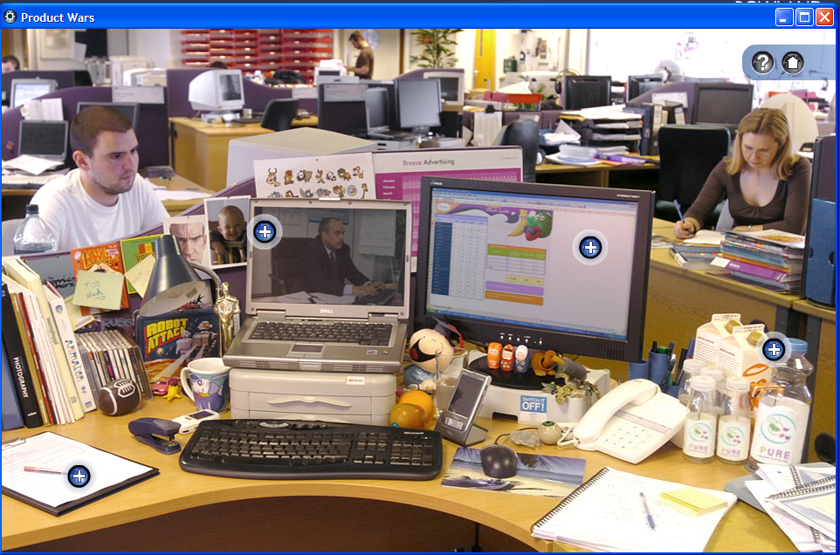

Observe how well pupils:  - Choose suitable questions  - Decide how to analyse the data  - Interpret their findings | 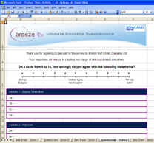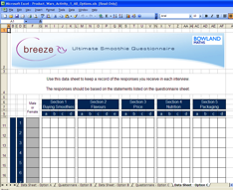  Questionnaire and Data Sheet – Option C
Questions to ask:
- What are the advantages/ disadvantages of using a scale of 1 to 10 like this?
- Who are you going to ask? Why? With more time, what would you do differently?
- Which of the three averages is most useful? Why? What other mathematical tools might be useful?

Assessment guidance: Progression in Key Processes

 | Representing | Analysing | Interpreting and evaluating
PROGRESSION | Needs teacher support to create questions and to identify appropriate tools for analysis | Presents data using simple tools, eg a bar chart, even if not in the most useful form  Pupil A | Interprets findings to draw simple conclusions, eg ‘6 people like banana’
 | Creates simple but unambiguous questions and chooses appropriate tools for analysis | Finds most averages correctly. Presents data appropriately and correctly, even if using simple tools | Summarises findings, eg ‘The most popular flavour is banana’  Pupil pair E (see page 9)
 | Creates unambiguous questions that will provide effective data and chooses appropriate tools for analysis  Pupil pair E (see page 9) | Analyses data correctly and presents findings appropriately and accurately using appropriate tools  Pupil pair E (see page 9) | Summarises findings, bringing together sub-categories, eg ‘Most females prefer banana and are willing to pay up to £2’
 | Identifies the most appropriate questions and tools for analysis, and can justify the choice | Analyses data correctly and appropriately to support a concise but detailed reasoned argument | Presents a concise but detailed reasoned argument using diagrams and related explanations

Sample response: Pupil A

Comments

This work was part of pupil A’s findings when asking the pre-formulated questions from option B. Her bar chart combined the four categories of response making it harder for her to assimilate and analyse the data.
Probing questions and feedback
- Why did you choose to present your findings in this way?
- Is there a better way to present your work so that you can draw useful conclusions quickly?

Pupil A would benefit from working with other pupils to discuss different ways of presenting data. Giving her opportunities to formulate her own questions is recommended.

Lesson 2: Ultimate Smoothie
Pupils create smoothies and make nutrition labels.
Teacher guidance
Options A, B and C all offer opportunities to assess Key Processes as pupils decide how to use proportional reasoning.
Observe how well pupils:  - Use and understand the spreadsheet  - Use proportional reasoning | 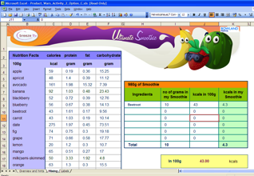  ‘Ultimate Smoothie’ − option C  (options A and B also available)
Questions to ask:
- How did you choose which ingredients to use?
- What problems did you encounter? How did you overcome them?
- What formula is used to calculate the number of kcals? Could you create formulae to help you with the rest of the task?

Assessment guidance: Progression in Key Processes

 | Representing | Analysing | Interpreting and evaluating
PROGRESSION | Needs teacher support to find appropriate methods | Chooses number of grams per ingredient to give the correct total | Reads the formulae correctly Pupil pair B
 | Selects an appropriate method to determine percentages  Pupil pair B | Recognises % must sum to 100 (option A)  Pupil pair B  Or independently uses simple proportional reasoning | Recognises that ‘÷ 100’ gives one gram
 | Selects an appropriate method to determine quantities per 100g (options B and C)  Pupil pair C | Uses proportional reasoning correctly and consistently | Understands the spreadsheet formulae
 | Selects an appropriate and efficient method to determine quantities per 100g (options B and C)  Pupil pair E (see page 9) | Uses proportional reasoning effectively  Pupil pair C  Pupil pair E (see page 9) | Understands and adapts the spreadsheet formulae  Pupil pair C  Pupil pair E (see page 9)

Sample response: Pupil pair B (option A)

Comments

The pupils used their own methods to work out percentages and understood that they must sum to 100. In discussion they recognised that the formula ‘includes 100 because % means 100 but we’re not really sure’.
Probing questions and feedback
- If there are 65kcals in 100g, how many kcals are in 1g? And if you know how many kcals are in 1g, how can you work out how many kcals are in 50g? or 80g? or … ?
- Now look at the formula … can you explain it?

Pupil pair B would benefit from working on other activities that use spreadsheets. This should enhance their knowledge and understanding of simple formulae.

Sample response: Pupil pair C (option B)
Comments

These pupils used four ingredients, each forming a quarter of the total. They used proportional reasoning, entering correct formulae into their own spreadsheet.
Probing questions and feedback
- Your label is supposed to show nutrition for 100g of smoothie, but yours is for 360g. What are the advantages of manufacturers showing nutritionper 100g?

Pupil pair C would benefit from being taught proportional reasoning using the unitary method. This should enable them to work more efficiently.

Lesson 3: Package Design

Pupils design and make a container for their smoothie.
Teacher guidance
In trials, some teachers showed the nets from one or more of options A, B or C depending on pupil ability, but then used the open-ended activity from option C.

Observe how well pupils:  - Determine the dimensions of their proposed container  - Create an accurate net  Worksheet: Option C | 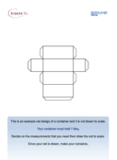

Questions to ask:
- How did you decide what shape to use? Did you consider other shapes?
- Will your container stack neatly on a shop shelf?
- How did you decide the dimensions? Was there a problem getting the right volume?
- How much cardboard is needed to make your container? Would manufacturers be able to produce your net in large quantities with little wastage? How might they do this?

Assessment guidance: Progression in Key Processes

 | Representing | Analysing | Interpreting and evaluating
PROGRESSION | Presents work in such a way that others could create the container  Pupil D | Shows understanding of simple nets  Pupil D | Produces a simple design and shows why it is appropriate  Pupil D
 | Uses diagrams and words effectively | Shows understanding of nets and the volume of cuboids | Checks the net and gives reasons why it is appropriate
 | Recognises that volume is dependent upon the dimensions of the cuboid  Pupil pair E (see page 9) | Draws an accurate net for a cuboid of volume 1000cm³ | As above, but also uses mathematical reasoning, eg ‘This shape will stack well’
 | Seeks to find more than one solution set | Draws an accurate net for a non-cuboid of volume 1000cm³  Pupil pair E (see page 9) | Considers a range of factors, eg cost, stacking and ease of production  Pupil pair E (see page 9)

Sample response: Pupil D

Comments

Pupil D chose to use squared paper to create a simple net. She provided values for surface area and volume but in discussion it was clear that she lacked confidence in how to find either. She stated that her design was good ‘because it is attractive and a handy size to fit in your bag’.
Probing questions and feedback
- Cut your net out and make it. Can you see where you have made a mistake? How could you avoid the same error in future?
- Explain how you found the (incorrect) surface area. What is the difference between surface area and volume? When might manufacturers wish to use each of them?
- You said your box holds 200cm³. How could you change your net so it makes a container that holds 1000cm³?

Pupil D would benefit from practical activities that would support her as she consolidates her knowledge and understanding of shape, space and measures.

Lesson 4: Presentation

Pupils present their recommended smoothie and its packaging, explaining and justifying decisions taken.
Teacher guidance
Observe how well pupils:
- Discuss their mathematics and communicate their findings
- Reflect on their approach
- Critique presentations by other groups

Questions to ask:
- What are the good selling points of your smoothie? Are there any disadvantages?
- On TV shows such as ‘Dragon’s Den’ or ‘The Apprentice’, people give presentations to convince others that their solution is the best. Can you strengthen your presentation to convince Brad King?
- What will you look for when the other groups present?

Assessment guidance: Progression in Key Processes

 | Communicating and reflecting
PROGRESSION | Explains some findings and decisions. Asks simple questions of other pupils, eg ‘How many people did you survey?’
 | Explains key findings and decisions, showing some insight into strengths and weaknesses of the approach. Offers simple improvements to other pupils, eg ‘Your net needs dimensions’.
Reviews the work throughout the task then gives a clear description of approach, findings and decisions. Reflects on how their own work can be improved; supports other pupils by making constructive suggestions for improvement.
Pupil pair E
 | Reviews their work throughout the task then gives a concise, detailed and appropriate summary of approach, findings and decisions. Reflects on strengths and weaknesses, and gives detail of how weaknesses could be overcome. Supports other pupils by making constructive and insightful suggestions for improvement.

Sample response: Pupil pair E

Comments

Pupil pair E summarised their research and findings to produce a reasoned argument. They did not draw the net, but they showed understanding of how to make a net for a cylinder. They listened to other groups’ presentation, asked relevant questions to challenge content.
Probing questions and feedback
- Think about the net for a cone and how it would help find the net for your container?
- It is good to show your calculations, – but is the accuracy appropriate? When should you round and why?

Pupil pair E would benefit from more work on this to help their geometry. Doing a survey beyond the classroom would also be helpful, especially if they then had to present their findings to an external person to help ensure their presentation was detailed but concise.

