|  |  |
| --- | --- |
| bpdlogo_bowlandb | You ReckonAssessing the learning |

|  |
| --- |
| Case Study description |

This case studycontains a range of tasks. Assessment guidance is given for three of them, although the same approach can be used for the other tasks.



**Suitability** National Curriculum levels 4 to 8

**Time** Each activity is independent and the amount of time required for each will vary according to the amount of research pupils undertake; a rough guide is 1 to 2 lessons.

**Resources** As for the case study; pupils would also benefit from access to the internet – although this ‘research’ aspect could be undertaken as homework.

**Opportunities to assess Key Processes**

* **Representing**: during activities 1, 2 and 3
* **Analysing**: during activities 1, 2 and 3
* **Interpreting and evaluating:** during activities 1, 2 and 3
* **Communicating and reflecting**: during activities 1, 2 and 3.

In addition to assessment of the Key Processes, there are opportunities to assess Range and Content (detail is within the case study) and some of the other personal, learning and thinking skills, particularly for ‘team working’.

|  |
| --- |
| Activity 1: Stop Thief! |



Pupils review an insurance claim.

**Teacher guidance**

This activity is most suitable for pupils working at NC levels 4 to 6.

|  |  |
| --- | --- |
| Observe how well pupils:   * Decide the information they need and how to use it * Work towards a solution, and then interpret it * Present their evidence and conclusion | Video: Stop! Thief! |

Questions to ask:

* *What do you need to know to solve the problem? How can you find this information?*
* *Do your answers seem realistic? How accurate do they need to be?*
* *Are there any alternative approaches you could have used?*

**Assessment guidance: Progression in Key Processes**

|  |  |  |  |  |
| --- | --- | --- | --- | --- |
|  | **Representing** | **Analysing** | **Interpreting and evaluating** | **Communicating and reflecting** |
| PROGRESSION | Identifies a relevant question, eg ‘How heavy is a £1 coin?’  Pupil A | Takes a relevant step towards the solution, eg finds the mass (or volume) of a £1 coin | Recognises the need to decide whether the mass (or volume) is realistic | Presents a report (oral or written), but key information is omitted Pupil A |
| Identifies relevant questions and recognises how to combine answers | Takes relevant steps, eg finds the mass (or volume) of 5000 £1 coins Pupil A | Uses knowledge of real life to determine whether the mass (or volume) is realistic | Presents a clear report (oral or written) that covers most issues  Pupil B |
| Identifies information needed and has a clear method for solution Pupil B | Implements a clear and correct method effectively Pupil B | Uses information to reach an informed conclusion Pupil B | Presents a clear and comprehensive report (oral or written) |
| Selects only the information needed and has a clear and concise method for solution | Implements a clear, correct and concise method effectively | Reaches an informed conclusion and realises that further work is not necessary | As above and shows evidence of reflection, eg that numbers used are estimates |

**Sample response: Pupil A**

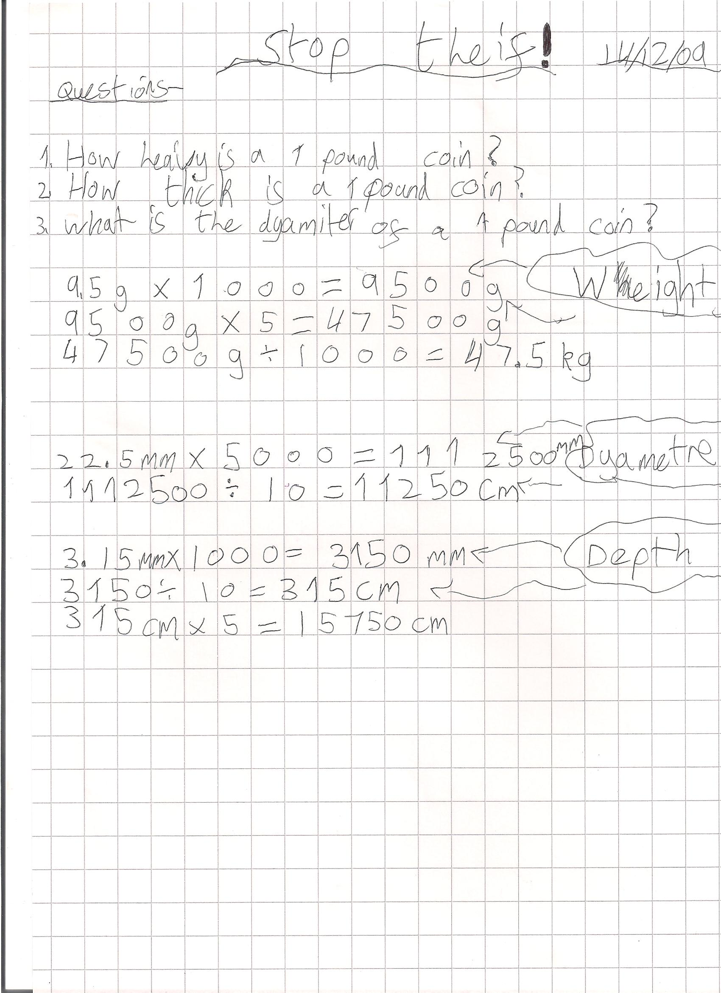

**Comments**

Pupil A works out the mass, diameter and depth (height) of 5000 £1 coins, but is then uncertain how to proceed.

**Probing questions   
and feedback**

* *Show me the diameter of a £1 coin. How would the coins be arranged to show 5000 of these diameters? Is that how the coins are arranged in bag of money that is being carried?*
* *What about depth? How would the 5000 coins be arranged? Does that help? Why not?*
* *What does 47.5kg ‘feel’ like? Does that help? How?*

Pupil A would benefit from working on a range of problems that include redundant information.

**Sample response: Pupil B**

**Comments**



Pupil B showed and interpreted relevant calculations, but then continued unnecessarily.

**Probing questions and feedback**

* *Are all things that weigh 10kg the same shape and size? What else can you think of that weighs 10kg, and could you carry it in one hand?*
* *To find the area of a coin, you did diameter (22.5cm) × depth (3.15mm). Why? What does that give the area of?*

Pupil B would benefit from working on other problems in which she must decide whether or not a solution has been reached. She also needs to develop her understanding of area of a range of shapes, including circles.

|  |
| --- |
| Activity 2: Mellow Yellow |

This activity focuses on saving water.

**Teacher guidance**

This activity is most suitable for pupils working at NC levels 5 to 7.

|  |  |
| --- | --- |
| Observe how well pupils:   * Decide the information they need and how to use it * Work towards a solution, and then interpret it * Present their evidence and conclusion | A useful source is www.waterwise.org.uk |

Questions to ask:

* *What do you need to know to solve the problem? How can you find it?*
* *Do your answers seem realistic? How accurate do they need to be?*
* *Are there any alternative approaches you could have used?*

**Assessment guidance: Progression in Key Processes**

|  |  |  |  |  |
| --- | --- | --- | --- | --- |
|  | **Representing** | **Analysing** | **Interpreting and evaluating** | **Communicating and reflecting** |
| PROGRESSION | Identifies a relevant question, eg ‘How many flushes per day per person?’ | Takes a relevant step towards the solution, eg no. of flushes multiplied by no. of people | Reaches partial conclusions | Presents a clear report (oral or written) that covers most issues |
| Identifies relevant questions and recognises how to combine answers | Combines data to take more than one relevant step towards the solution | Reaches an informed conclusion Pupil C | Presents a clear and comprehensive report (oral or written) Pupil C |
| Identifies information needed and has a clear method for solution Pupil C | Implements a clear and correct method effectively Pupil C | Reaches an informed conclusion, using appropriate accuracy | As above and shows evidence of reflection, eg that nos. used are estimates |
| Selects only the information needed and has a clear and concise method for solution | Implements a clear, correct and concise method effectively | As above and processes findings to make them accessible, eg uses percentages | As above and reflects on the limitations surrounding the findings |

**Sample response: Pupil C**

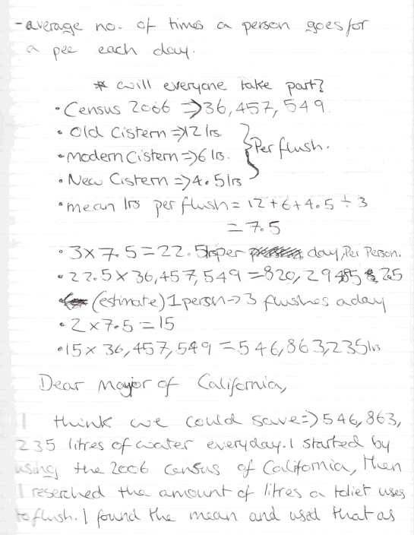

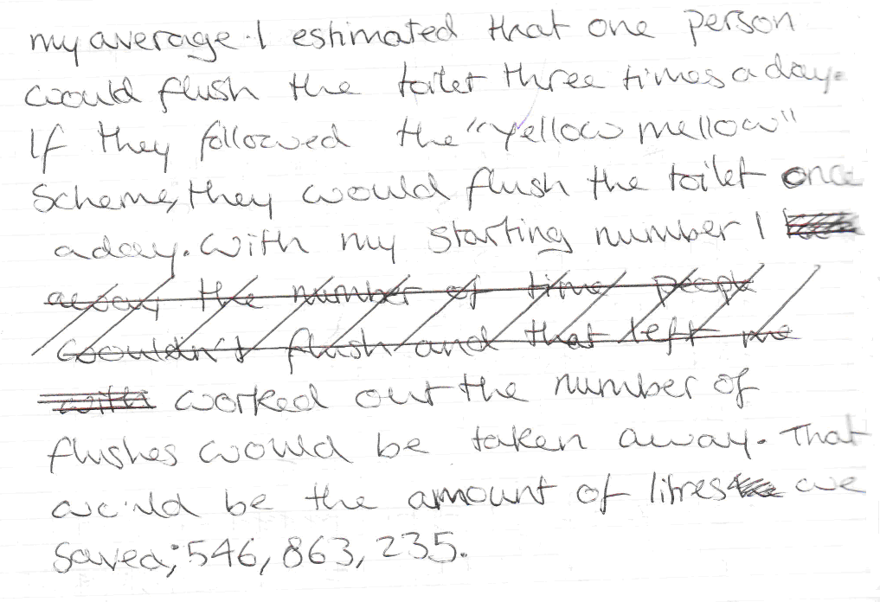

**Comments**

Pupil C formulates her own questions and researches the information needed.

**Probing questions and feedback**

* *When you found the mean number of litres per flush, what assumptions did you make about the numbers of different types of cisterns people use?*
* *What accuracy would have been more appropriate and why?*
* *Can you think of a way of helping the reader by explaining what 546 million litres of water ‘looks’ like?*

Pupil C would benefit from discussions about what accuracy is appropriate when solving problems, and why.

Reviewing other pupils’ work may support her understanding of how to produce an effective summary report.

|  |
| --- |
| Activity 3: Blow Dry |

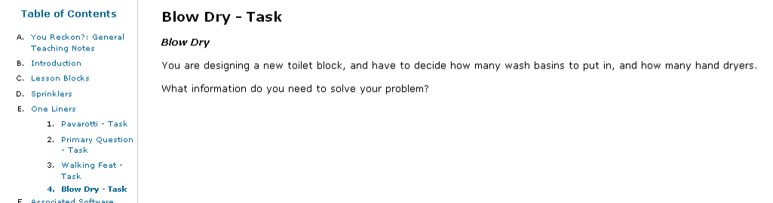

This activity is to design a toilet block.

**Teacher guidance**

The provision of a context, eg a cinema, provides an activity is suitable for pupils working at levels 6 to 8.

|  |  |
| --- | --- |
| Observe how well pupils:   * Decide what information is needed and how to use it * Work towards a solution, and then interpret it * Present their evidence and conclusion | A useful source is  www.hse.gov.uk/ contact/faqs/toilets.htm |

Questions to ask:

* *What do you need to know to solve the problem? How can you find it?*
* *Do your answers seem realistic? How accurate do they need to be?*
* *Are there any alternative approaches you could have used?*

**Assessment guidance: Progression in Key Processes**

|  |  |  |  |  |
| --- | --- | --- | --- | --- |
|  | **Representing** | **Analysing** | **Interpreting and evaluating** | **Communicating and reflecting** |
| PROGRESSION | Identifies relevant questions and how to combine answers | Combines data; takes relevant steps towards the solution | Reaches an informed conclusion | Presents a clear and comprehensive report (oral / written) |
| Identifies information needed and has a clear method for solution | Implements a clear and correct method effectively | Reaches an informed conclusion, using appropriate accuracy | As above and shows evidence of reflection, eg that nos. used are estimates |
| Selects only info. needed and has a clear and concise method for solution | Implements a clear, correct and concise method effectively Pupil F | As above; processes findings to make them accessible, eg uses % Pupil F | As above; reflects on the limitations surrounding the findings Pupil F |
| As above; collects clear data that gives insight into the problem Pupil F | As above; uses a range of appropriate strategies to test findings | As above; critically examines strength of evidence within the detailed solution | As above; gives insightful ways of how the solution could be improved |

**Sample response: Pupil pair D and E**

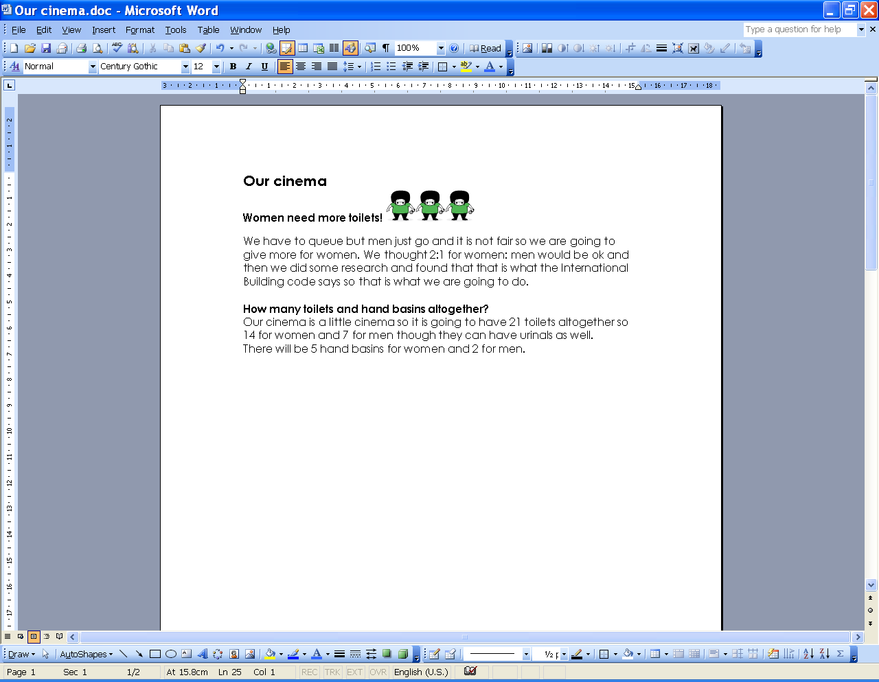

**Comments**

These pupils focus on the number of toilets. They explain their choice of 2:1 but not their final solution.

**Probing questions and feedback**

* *Why did you choose 2:1 as the ratio?*
* *How did you decide on 21 toilets?*
* *How confident are you that it is a cost effective solution?*

Pupils D and E would benefit from reviewing work done by confident problem solvers who are able to make and justify the assumptions and approximations needed for real life situations – see Pupil F below.

**Sample response: Pupil F**

**Comments**

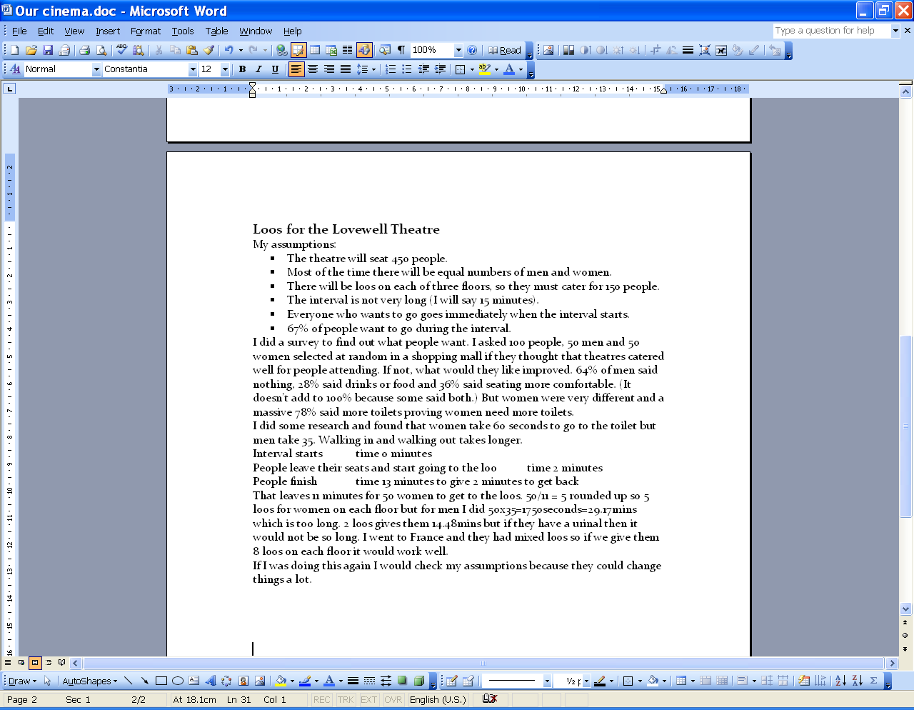

Pupil F created a simple mathematical model to develop a solution.

**Probing questions and feedback**

* *Would your conclusions change if you assumed that people arrive at the loos throughout the interval?*

Pupil F would benefit from learning how to create a simple simulation to model people arriving and leaving. This would enable her to test and extend her outline conclusions.